

PROJECT TITLE | TECH WORKFORCE SALARY & FINANCIAL ANALYTICS DASHBOARD
PROJECT CATEGORY | HR Analytics Salary Analytics Financial Analytics Workforce Analytics
INSTITUTE NAME | Infinity Code Nexus
TRAINER / GUIDE | Mr. Anand Kumar
CREATED BY | Mr. Seepathi Ram Sai
TOOLS USED | Power BI Desktop Power Query, DAX & Power BI Service
SUBMISSION DATE | [14/06/2026]

Prepared as part of the Power BI Masterclass Program to demonstrate skills in Data Analysis, Data Modeling, DAX Development, Dashboard Design, UI/UX, Storytelling, and Business Intelligence Reporting.

PROJECT OVERVIEW
================================================================

PROJECT OBJECTIVE
Develop an interactive Power BI dashboard to analyze employee salaries, career growth, expenses, savings, skills, certifications, and job satisfaction within the technology industry. The dashboard helps stakeholders understand workforce trends and make data-driven HR and financial decisions.
✔ Analyze salary structures
✔ Evaluate career growth
✔ Understand employee expenses
✔ Analyze savings patterns
✔ Assess job satisfaction
✔ Generate business insights

PROJECT GOAL

Transform workforce and financial data into meaningful insights regarding employee compensation, professional development, financial well-being, and satisfaction levels.

BUSINESS PROBLEM
Organizations need answers to the following questions:
- Which technology fields offer the highest salaries?
- Which job roles receive the highest compensation?
- How does education impact salary?
- Do certifications improve earning potential?
- How do expenses and savings vary among employees?
- Which work arrangements lead to higher job satisfaction?

- Which employees are most likely to seek new opportunities?

DATASET INFORMATION
================================================================
DATASET NAME : Tech Salary Dataset
DATASET DETAILS : Approximate Records 10,000+ Columns : 50

Key Fields
- Employee ID
- Annual Salary
- Bonus Percentage
- Education Level
- Job Title
- Tech Field
- Work Arrangement
- Employment Type
- Company Size
- Certifications
- Savings
- Expenses
- Job Satisfaction Score
- Experience Years

POWER QUERY TRANSFORMATIONS
================================================================
Data Cleaning
- Removed duplicate records
- Replaced null values
- Corrected data types
- Standardized categorical values
- Renamed columns
- Removed unnecessary columns

DATA PREPARATION ACTIVITIES
✔ Renamed Columns
✔ Created Custom Columns
✔ Replaced Values
✔ Split Columns
✔ Merged Columns
✔ Removed Unnecessary Columns

CUSTOM COLUMNS CREATED
================================================================
Salary Category Experience Group Savings Category Age Group Certification Status

SCREENSHOT

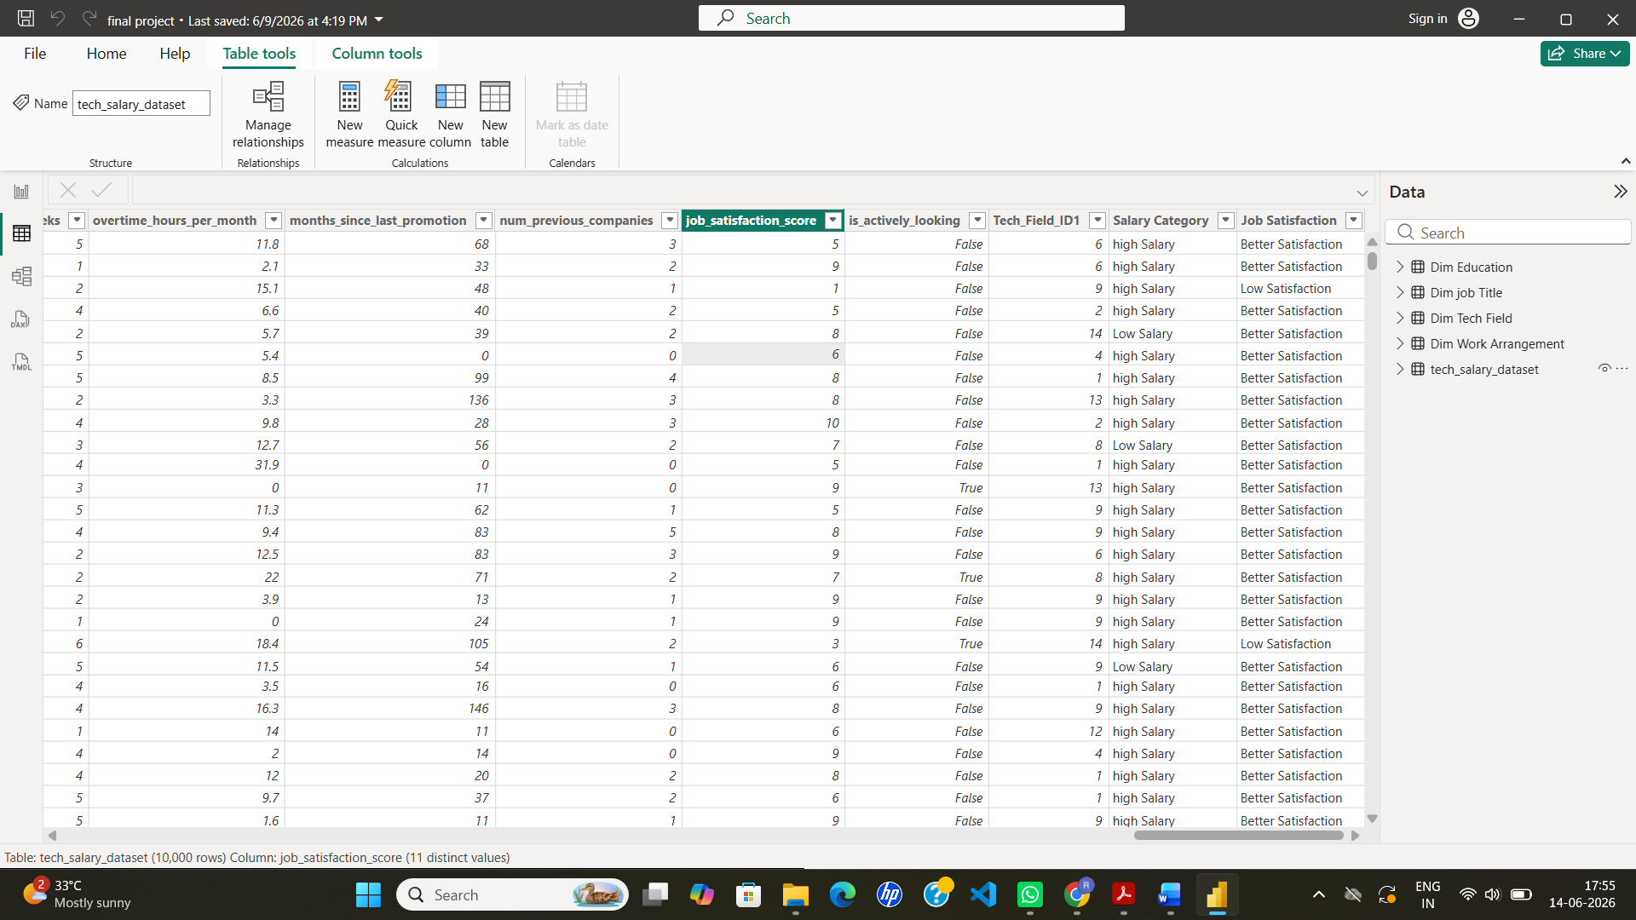

DATA MODELING
================================================================

Star Schema
================================================================
Purpose:
FACT TABLE
Employee_Fact DIMENSION TABLES
Dim_Location Dim_Tech_Field Dim_Job_Title Dim_Education
Dim_Work_Arrangement

RELATIONSHIPS
One-to-Many Relationships

FILTER DIRECTION
Single Direction

MODEL BENEFITS
Improved Performance Easy DAX Development Better Scalability
SCREENSHOT

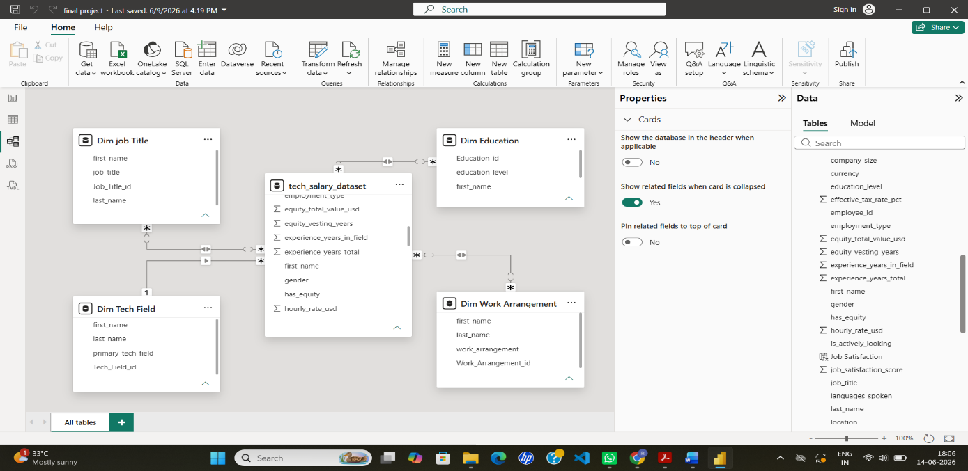

DAX MEASURES USED
================================================================ TOTAL EMPLOYEES
DISTINCTCOUNT('tech_salary_dataset'[employee_id])
PURPOSE : Calculate total workforce count.

AVERAGE SALARY
AVERAGE('tech_salary_dataset'[annual_salary_usd
PURPOSE : Calculate average annual salary.\

AVERAGE SAVINGS
AVERAGE('tech_salary_dataset'[annual_savings_usd])
PURPOSE : Calculate average of salary saved.

AVERAGE EXPERIENCE
AVERAGE('tech_salary_dataset'[experience_years_total])
PURPOSE : Calculate average of experience.

AVERAGE BONUS %
AVERAGE('tech_salary_dataset'[bonus_percentage])
PURPOSE : Calculate average Percentage of salary saved.

VISUALIZATIONS USED
================================================================
KPI CARDS: Display key business metrics.

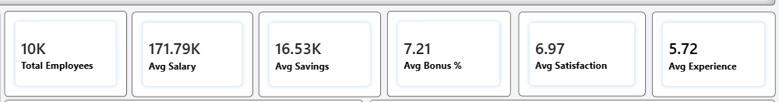

BAR CHART: Compare salary and savings.

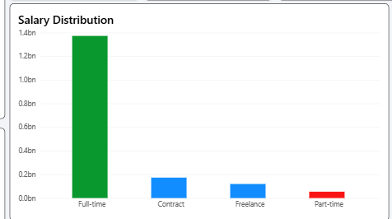

LINE CHART: Show trends over time.

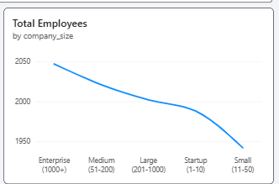

DONUT CHART:

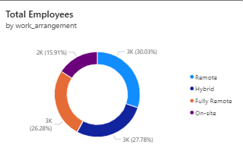

DASHBOARD SCREENSHOTS
================================================================ EXECUTIVE OVERVIEW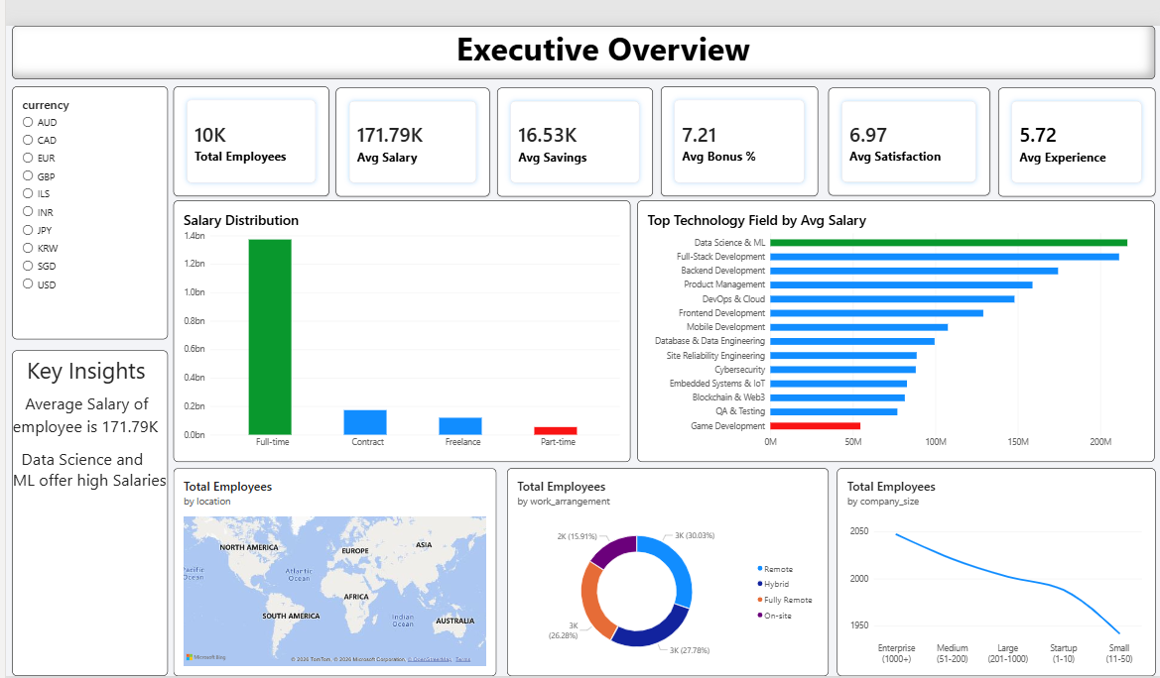
EXPLANATION:
Purpose
Provides a high-level summary of workforce performance and financial metrics.
KPIs
- Total Employees: 10K
- Average Salary: 171.79K
- Average Savings: 16.53K
- Average Bonus: 7.21%
- Average Satisfaction: 6.97
- Average Experience: 5.72 Years
Insights
- Full-time employees contribute the highest salary volume.
- Data Science & ML is the highest-paying technology field.
- Remote work arrangement has the largest employee share.
- Enterprise companies employ more professionals than startups.

SALARY ANALYTICS
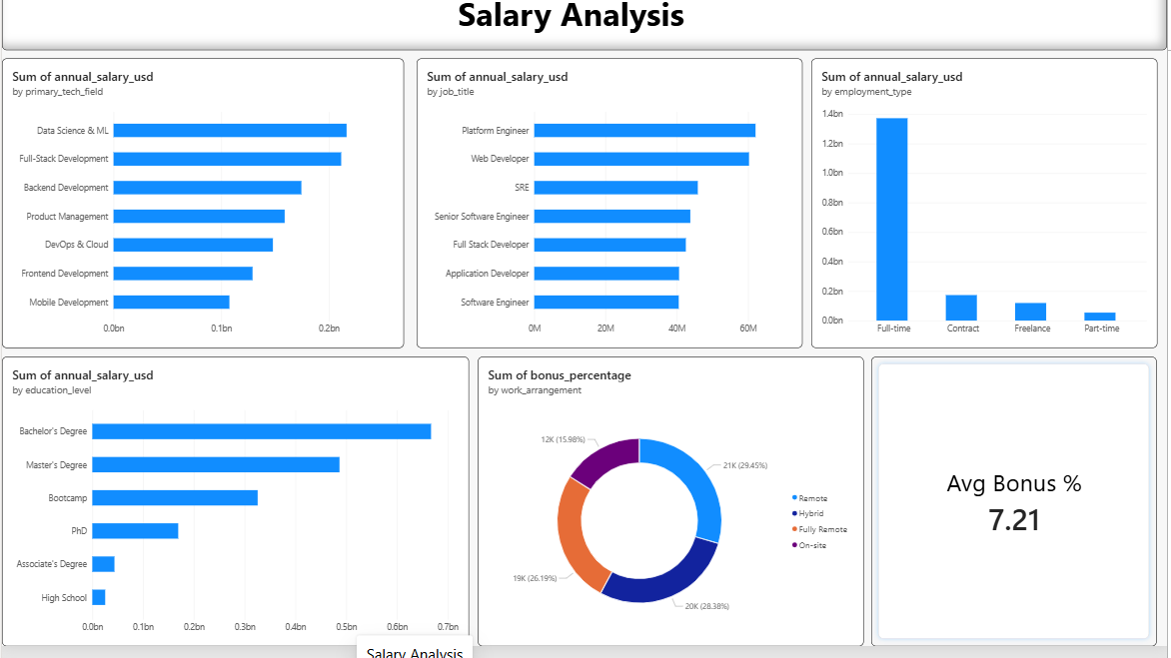
Explanation
Purpose

Analyze salary distribution across technology fields, job roles, education levels, and employment types.

Insights
- Data Science & Machine Learning receives the highest salary compensation.
- Platform Engineers are among the highest-paid professionals.
- Full-time employees earn significantly more than contract or freelance workers.
- Bachelor's and Master's degree holders receive the highest overall salary contributions.
- Remote employees receive higher average bonus percentages.

CAREER GROWTH ANALYTICS
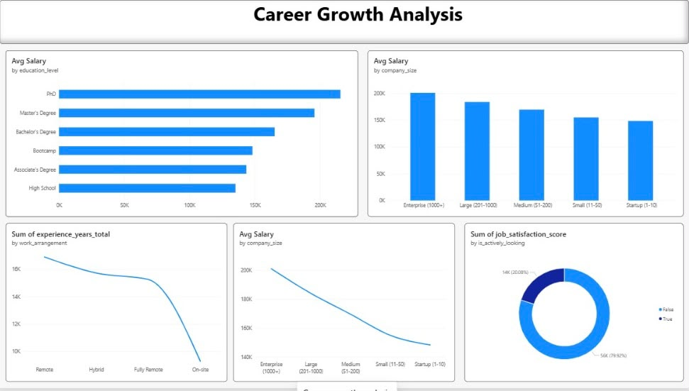
Explanation
Purpose

Analyze salary growth using education, company size, experience, and job satisfaction.

Insights

- PhD holders receive the highest average salaries.
- Enterprise companies provide the highest salary packages.
- Remote employees have the highest experience levels.
- Employees not actively looking for jobs show higher satisfaction scores.
- Salary decreases gradually as company size becomes smaller.

EXPENSES AND SAVINGS ANALYTICS

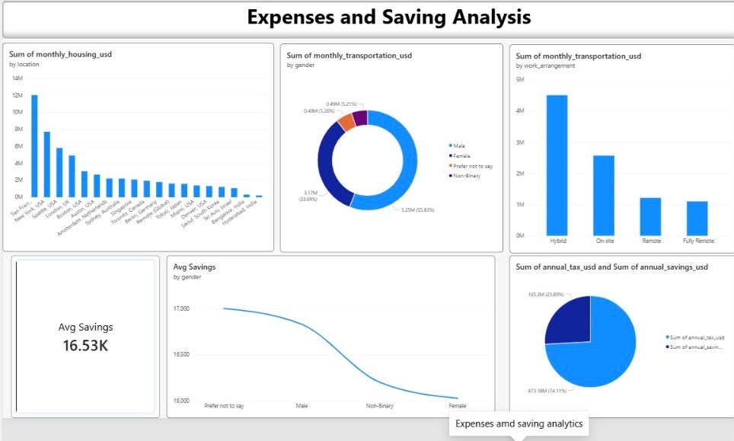

Purpose

Evaluate employee expenses and savings behavior.

Insights

- San Francisco has the highest housing expenses.
- Hybrid employees incur higher transportation costs.
- Average employee savings amount is 16.53K.
- Tax deductions form a major portion of employee financial outflow.
- Male employees contribute the highest transportation expenses.

SKILLS AND CERTIFICATIONS ANALYTICS

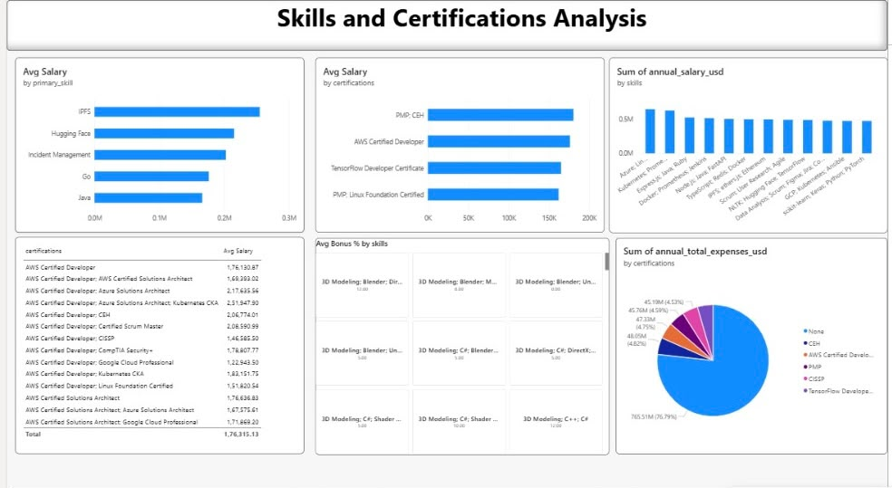

Purpose

Analyze the impact of technical skills and certifications on salary.

Insights

IPFS and Hugging Face skills have the highest average salaries.

PMP and CEH certifications generate higher average salaries.

Kubernetes and Cloud-related skills contribute significantly to salary earnings.

Employees with professional certifications earn more than non-certified employees.

Technical specialization directly impacts compensation.

EMPLOYEE SATISFACTION ANALYTICS

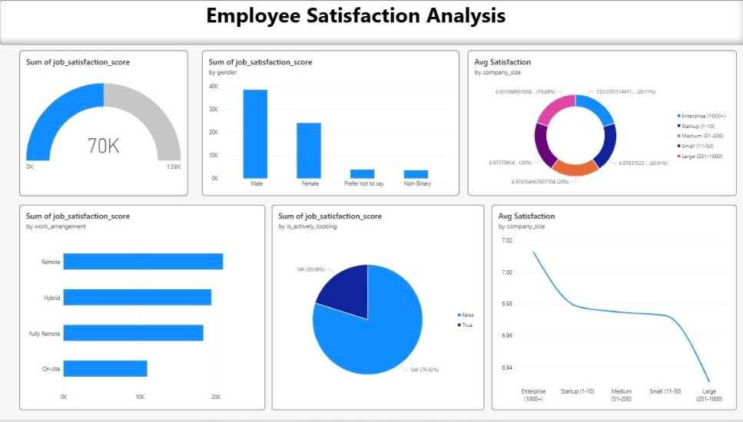

Purpose

Measure employee satisfaction across demographics and work environments.

Insights

Male employees have the highest overall satisfaction score contribution.

Enterprise companies show the highest average satisfaction levels.

Remote employees demonstrate greater job satisfaction than on-site employees.

Employees not actively seeking jobs show higher satisfaction.

Larger organizations maintain stronger employee satisfaction levels.

KEY INSIGHTS
================================================================ INSIGHT-1
Data Science & Machine Learning professionals receive the highest salary packages across technology field.

INSIGHT-2

Professional certifications such as PMP and CEH positively impact employee earnings.

INSIGHT-3

Remote and flexible work arrangements improve employee satisfaction

INSIGHT-4

Enterprise organizations provide higher compensation and satisfaction levels.

INSIGHT-5

Employees with higher education levels achieve greater salary growth opportunities.

BUSINESS RECOMMENDATIONS
================================================================ RECOMMENDATION-1
Invest in employee certification and upskilling programs.

RECOMMENDATION-2

Promote flexible and remote work policies to improve satisfaction.

RECOMMENDATION-3

Develop retention strategies for highly skilled technical professionals.

RECOMMENDATION-4

Provide financial wellness initiatives to improve employee savings behavior.

RECOMMENDATION-5

Create career growth pathways for employees through education and training support.

FEATURES IMPLEMENTED
================================================================

- KPI Cards
- Slicers
- Drill Down
- Drill Through
- Interactive Charts
- Map Visualization
- Dynamic Filtering
- Conditional Formatting
- Navigation Between Pages

CHALLENGES FACED
================================================================
Data Cleaning Challenges Relationship Management DAX Optimization Dashboard Layout Design Performance Tuning

LEARNINGS
================================================================
Power Query Data Modeling
DAX Development Dashboard Design Storytelling Business Analysis

PROJECT STORYTELLING
================================================================

BUSINESS SCENARIO
Technology organizations generate large amounts of workforce data related to salaries, experience, skills, expenses, savings, and employee satisfaction.
However, decision-makers often struggle to convert this information into meaningful business insights that support workforce planning and employee retention.

BUSINESS PROBLEM
- Which technology fields provide the highest compensation?
- How does experience affect salary growth and financial stability?
- Do certifications and specialized skills increase earnings?
- Which employees demonstrate better savings behavior?
- What factors influence employee satisfaction and retention?

ANALYSIS APPROACH
- Analyzed workforce compensation across technology domains.
- Compared salary growth against experience and education levels.
- Evaluated employee expenses and savings patterns.
- Measured the impact of skills and certifications on earnings.
- Analyzed job satisfaction and retention indicators.

KEY FINDINGS
================================================================
Employees with specialized technical skills earned higher salaries.
Certified employees demonstrated better compensation growth.
Experienced employees maintained higher savings rates.
Remote and flexible work arrangements showed higher satisfaction scores.
================================================================

BUSINESS IMPACT
================================================================
Supports compensation planning. Improves workforce development. Enhances employee retention strategies. Provides data-driven HR insights.
Enables better workforce decision-making.

PROJECT DEPLOYMENT
================================================================ DEPLOYMENT OBJECTIVE
Deploy the Power BI solution to enable stakeholders to access interactive dashboards and business insights in real time.

DEPLOYMENT PLATFORM
Power BI Service

DEPLOYMENT PROCESS
Power BI Service

STEP-1
Validate Data Model and DAX Measures in Power BI Desktop.

STEP-2
Optimize Dashboard Layout, Performance, and User Experience.

STEP-3
Publish PBIX File to Power BI Service.

STEP-4
Configure Dataset Refresh Settings.

STEP-5
Create Dashboard from Published Reports.

STEP-6
Apply Security and Access Permissions.

STEP-7
Share Dashboard with Business Stakeholders.

BUSINESS BENEFITS
Centralized Reporting Platform. Interactive Workforce Analytics. Real-Time Performance Monitoring. Improved Strategic Planning
Faster Data-Driven Decisions.

CONCLUSION
================================================================
The Tech Workforce Salary & Financial Analytics Dashboard successfully analyzes employee compensation, career progression, financial behavior, skills, certifications, and satisfaction levels. The dashboard enables HR teams and business leaders to identify workforce trends, optimize compensation strategies, improve employee retention, and support data-driven decision-making.

